GUIDE FOR THE ISSUANCE OF DIPLOMATIC IDENTITY DOCUMENTS ANNEXURE 2
IDENTITY CARD CLASS | TYPE OF IMMUNITY AND PRIVILEGES – QUALIFYING RANKS | EXAMPLE OF ID CARD
Diplomatic Agent | Full Diplomatic Immunity (Act 37 of 2001) | 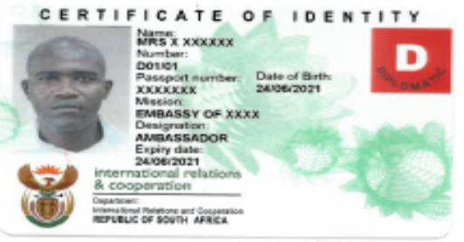  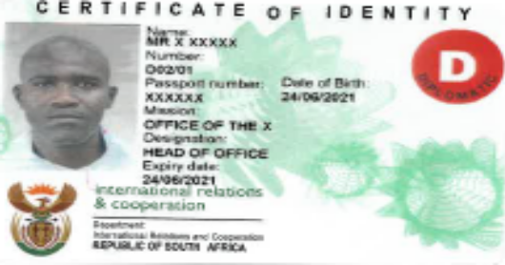  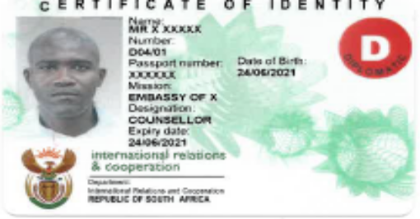
The holder of this card has been accorded diplomatic status by the RSA Government and enjoys immunity from criminal jurisdiction and may not be arrested or detained. | - Heads of Diplomatic Missions  - * Heads of I/O at level P5 and D1 only  - Diplomatic Agents who hold Diplomatic Ranks  - Defence/Military Attachés  - Full Privileges  - Spouse and dependent family members accredited as per DIAP Policy
Consular Officer | Consular Immunity (Act 37 of 2001) | 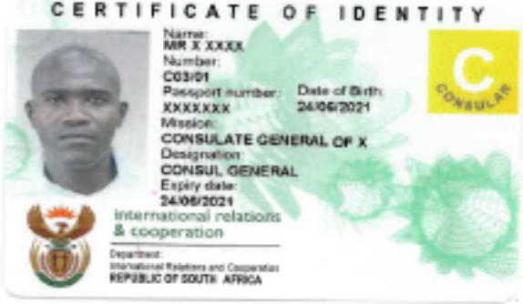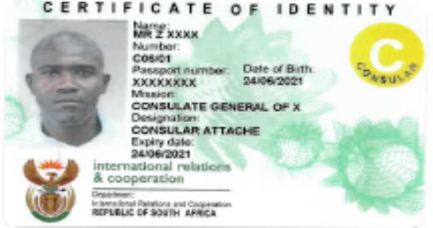
The holder of this card has been accorded consular status by the RSA Government and enjoys immunity from criminal jurisdiction in respect of acts performed in the exercise of consular functions only and may not be arrested or detained pending trial. | - Heads of Consular Missions  - Consul General  - Consul  - Vice-Consul  - Consular Officer holding Consular Ranks  - Functional Immunity  - Full Privileges
International Organisation I * | Full Diplomatic Immunity (Act 37 of 2001) | 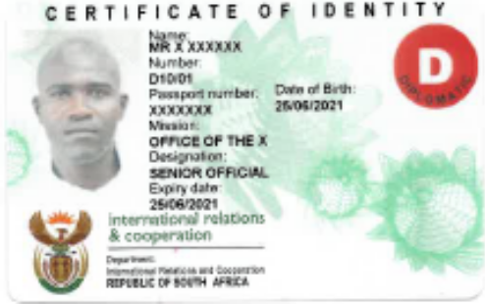
The holder of this card has been accorded diplomatic status by the RSA Government and enjoys immunity from criminal jurisdiction and may not be arrested or detained. | - Officials accredited to International Organisations  - Heads of I/O’s  - Full Immunity  - Full Privileges  NB:  South African nationals and Permanent Residents are conferred with functional immunities and no privileges
Honorary Consul | Functional Immunity Only (Act 37 of 2001) | 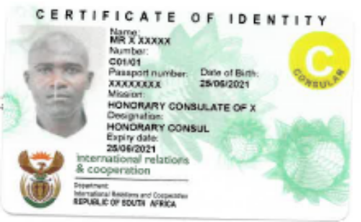
The holder of this card has been accorded honorary consular status by the RSA Government and enjoys immunity from criminal jurisdiction in respect of acts performed in the exercise of his/her consular functions only. | - Honorary Consular Staff  - Functional Immunity  - No Privileges
Administrative & Technical | Functional Immunity Only (Act 37 of 2001) | 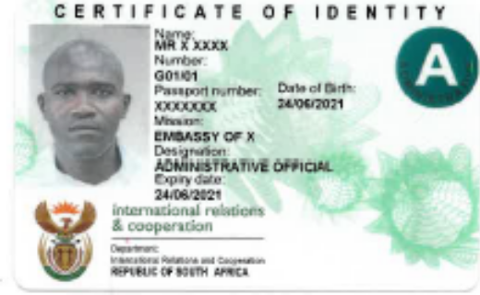
The holder of this card has been accorded administrative status by the RSA Government and enjoys immunity from criminal jurisdiction in respect of acts performed in the exercise of administrative functions only and may not be arrested or detained pending trial. | - Administrative & Technical Staff in Diplomatic Missions  - Functional Immunity  - First Installation (Appointment) Privileges (6 Months) only
Consular Employee | Consular Immunity (Act 37 of 2001)
The holder of this card has been accorded consular status by the RSA Government and enjoys immunity from criminal jurisdiction in respect of acts performed in the exercise of his/her consular functions only and may not be arrested or detained pending trial. | - Consular Administrative & Technical Staff:  - Administrative Officer  - Functional Immunity  - First Installation (Appointment) Privileges (6 Months) only
International Organisation II | Functional Immunity (Act 37 of 2001) | 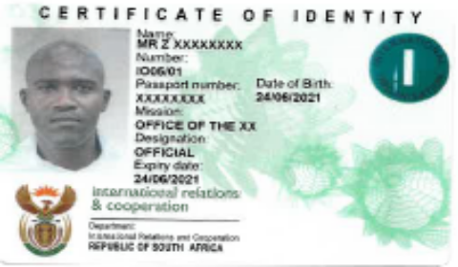
The holder of this card has been accorded diplomatic status by the RSA Government and enjoys immunity from criminal jurisdiction in respect of acts performed in the exercise of official functions only and may not be arrested or detained pending trial. | - Officials, Experts, Consultants Administrative & Technical Staff in International Organisations  - Functional Immunity  - First Installation Privileges (6 Months)  NB:  South African nationals and Permanent Residents are conferred with functional immunities and no privileges
Employed Spouses | Immunities Limited (Act 37 of 2001) | 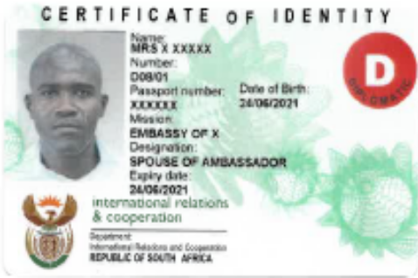  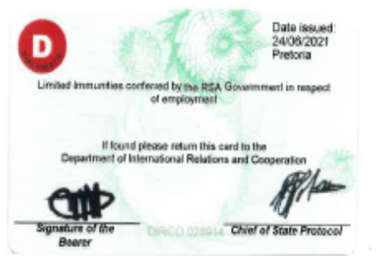
Limited immunities conferred by the RSA Government in respect of Spousal Employment. | - In the case of spousal employment  - Full immunities reinstated outside of normal working hours
Private Introduced Servants | No Immunities Accorded (Act 37 of 2001) | 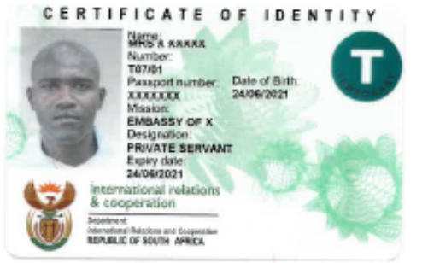
Introduced domestic staff, no immunities accorded by the RSA Government. | - For private servants of Ambassadors and High Commissioners only  - No Immunities  - No privileges

